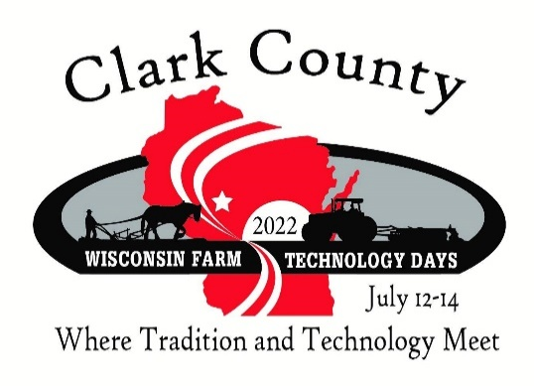
CLARK COUNTY
proudly presents
WISCONSIN FARM TECHNOLOGY DAYS 2022
hosted by Roehl Acres & Rustic Occasions in Loyal

CONTRIBUTION AGREEMENT

Contributor: ____________________________
(As you would like it to appear on all signage)
Contact: ________________________________
Address: ________________________________
City: _____________ State: _____ Zip: ________
Email: __________________________________
Website: ________________________________
Payment Options (check one):
- Payment included with form: Amount $__________ Check # ___________
- Invoice for full amount (Payment received no later than April 2022)
Equal yearly installments (for contributions of $1,000 or more) $___________ by 12/30/2021
$___________ by 3/1/2022
In-Kind Contributions
Item Qty. $ Value
_______________________ ____________________ ______________________
_______________________ ____________________ ______________________
_______________________ ____________________ ______________________
(Contributors will be recognized at the appropriate level based upon the dollar value of the contribution.)

Acknowledgement:
___________________________________ ___________________________ _____________
Contributor’s Signature Clark County FTD Representative Date
Contributions to Clark County FTD support the following:
- Educational programs at Farm Technology Days in the areas of agriculture, family living and youth
- Pre-event expenses, Farm Technology Days promotions
- Youth activities and agricultural programs
Please mail this form and make checks payable to:
Wisconsin Farm Technology Days
c/o Clark County Farm Tech Days
Jim Mildbrand
303 N Division St.
Loyal, WI 54446
If the entire show is cancelled Exhibitors will be allowed to request refunds of their fees paid. Clark County Farm Technology Days 2022 reserves the right to pro-rate refunds if monies have already been expended to support the show.

For questions, please call Jim (Funds Development Committee Chair) at 715-797-8356
Email jim.mildbrand@gmail.com

